MULTI-CLASS-CLASSIFICATION

# AIM:

Towriteapythonprogramtoimplementthemulticlassclassificationalgorithm.

# EQUIPMENTS REQUIRED:

1. Hardware – PCs
2. Anaconda – Python 3.7 Installation / Moodle-Code Runner / Google Colab

# RELATEDTHEORITICALCONCEPT:

In multi-class classification, the neural network has the same number of output nodes as thenumber of classes. Each output node belongs to some class and outputs a score for that class.Class is a category for example Predicting animal class from an animal image is an example ofmulti-class classification, where each animal can belong to only one category.

# ALGORITHM:

1. Import the necessary modules
2. Frame the dataset using make_blobs
3. Assign the counter value using the Counter function
4. Using a for loop, plot the points using scatter function

# PROGRAM:

/*

Programtoimplementthemulticlassclassifier.Developedby:moneesh

RegisterNumber:212219040081

*/

fromnumpyimportwhere

fromcollectionsimportCounter

fromsklearn.datasetsimportmake_blobsfrommatplotlibimportpyplot

X,y=make_blobs(n_samples=1000,centers=3,random_state=1)print(X.shape,y.shape)

counter=Counter(y)

print(counter)

foriinrange(10):print(X[i],y[i])

forlabel,_incounter.items():row_ix=where(y==label)[0]

pyplot.scatter(X[row_ix,0],X[row_ix,1],label=str(label))pyplot.legend()

pyplot.show()

# OUTPUT:

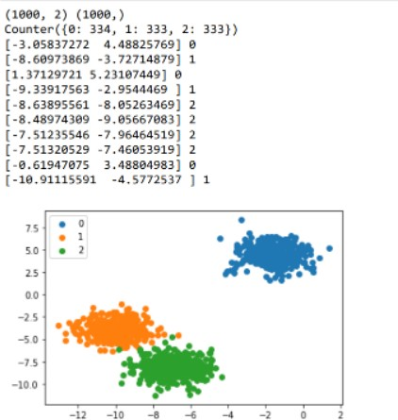

RESULT:

Thus the python program to implement the multi class classification was implemented successfully.